Quantum Spectral Clustering / Quantum Community Detection

1. Problem
Spectral clustering and community detection are widely used unsupervised learning techniques for identifying structure in graphs and datasets. They rely on the eigenvalues and eigenvectors of graph Laplacians to partition nodes into communities.
Classically, spectral methods require expensive eigen-decompositions, which become infeasible for very large graphs. Quantum spectral clustering aims to accelerate these computations using quantum linear algebra and quantum phase estimation.

2. Intuition
The intuition behind quantum spectral clustering is:
- Represent the graph (or similarity matrix) as a quantum operator
- Use quantum algorithms to extract important eigenvectors of the graph Laplacian
- Perform clustering based on these eigenvectors
Quantum algorithms can, in principle, estimate eigenvalues and eigenvectors exponentially faster under certain assumptions.

3. Algorithm / Circuit Structure
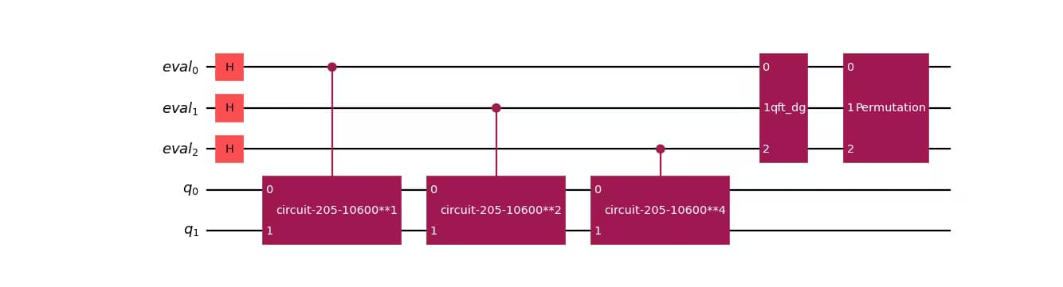
A typical quantum spectral clustering pipeline consists of:
- Graph Encoding
Encode the adjacency matrix or Laplacian as a quantum operator.
- Quantum Phase Estimation (QPE)
Extract eigenvalues and eigenstates of the Laplacian.
- Eigenvector Filtering
Select low-frequency (small eigenvalue) components.
- Measurement & Classical Clustering
Measure quantum states and apply classical clustering (e.g., k-means).

4. Simple Math Involved
- Graph Laplacian: [ L = D - A ]
- Spectral decomposition: [ L = _i _i |u_iu_i| ]
- Clustering rule:
Nodes are clustered based on the components of the eigenvectors corresponding to the smallest non-zero eigenvalues.

5. Python Code (Quantum Spectral Clustering – Algorithm)
import numpy as np
from qiskit import QuantumCircuit
from qiskit.primitives import Sampler
A = np.array([
[0, 1, 1, 0],
[1, 0, 1, 0],
[1, 1, 0, 0],
[0, 0, 0, 0]
])
D = np.diag(np.sum(A, axis=1))
L = D - A
eigenvalues, eigenvectors = np.linalg.eigh(L)
fiedler_vector = eigenvectors[:, 1]
clusters = {
0: np.where(fiedler_vector >= 0)[0].tolist(),
1: np.where(fiedler_vector < 0)[0].tolist()
}
print("Quantum-inspired spectral clustering result:")
print(clusters)

6. Where the Algorithm Is Useful
- Community detection in networks
- Graph partitioning
- Social network analysis
- Biological network analysis

7. Limitations
- Requires efficient Hamiltonian simulation
- QRAM assumptions are strong
- Current hardware limits scalability
- Mostly theoretical quantum advantage

8. Comparison with Classical Spectral Clustering
- Eigen-decomposition: Classical O(n³) vs. quantum polylog(n) (ideal case)
- Data access: Classical RAM vs. QRAM
- Maturity: Classical methods are mature; quantum methods are experimental
- Output: Both produce classical cluster labels

9. One-Sentence Summary
Quantum spectral clustering uses quantum eigenvalue estimation to identify communities in graphs more efficiently than classical spectral methods.

